
Company
Logotype

Cone Beam Computed Tomography- Report



Porur Dental X-rays & CBCT

Patient Name : Miss. Kavinaya | Date of Report : 18.03.2024
Age/ Gender : 18 years/ Female | Region of Interest : CBCT Sectional Maxilla
Referring doctor: Dr. Balamurali Sai | Indication : Impacted tooth
Clinical Notes: Nil
PATIENT INFORMATION

CBCT Sectional Mansible provided
CBCT – IMAGE DETAILS

RADIOGRAPHIC INTERPRETATION

- No of teeth present in the maxillary and mandibular alveolar ridge: 35
- Deciduous teeth: 53, 73;
- The tooth 13 appears to be within the alveolar bone, distally tipped and lies above the periapical aspect of the deciduous tooth: 53.
- The tooth 23 appears to be obliquely, horizontally placed within the alveolar bone with its crown above the periapical aspect of 22 and its root in proximity to the medial wall of left maxillary sinus.
- In relation to 32, 33 region, presence of an additional tooth structure (with normal morphological features of crown and root) that appears impacted between the radicular portion of 32 and 73. This occlusal plane of this tooth appears to be in line with the middle third of the root of 32.
- The tooth 33 appears to be within the alveolar bone between the periapical aspect of 73 and radicular portion of 34.
- Developing crowns of 18, 28, 38, 48.

- Distance between the alveolar ridge and 13: 2.5 mm
- Distance between the alveolar ridge and 23: 5.7 mm
- Distance between the alveolar ridge and 33: 6.2 mm
- Distance between the mental foramen and 33: 6.4 mm
- Distance between the alveolar ridge and impacted supernumerary tooth: 1.3 mm
- Complete hyperdense opacification of the right maxillary sinus is evident.

RADIOGRAPHIC IMPRESSION


- Impacted supernumerary tooth : 32, 33 region.
- Impacted teeth: 23, 33
- Permanent successor: 13
- Right maxillary sinusitis.

IMAGES FOR REFERENCE

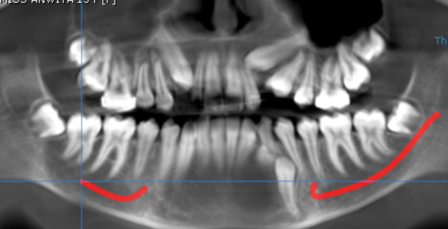
PANORAMA VIEW
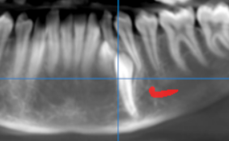
CROSS- SECTIONAL IMAGES
13 REGION | 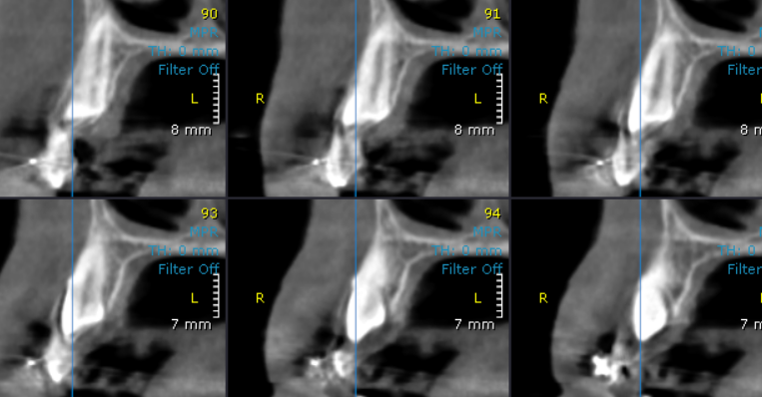
23 REGION | 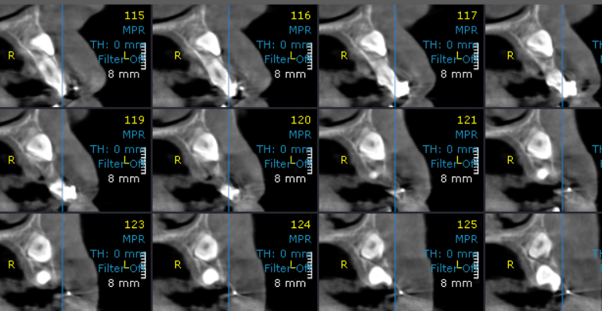
33 REGION | 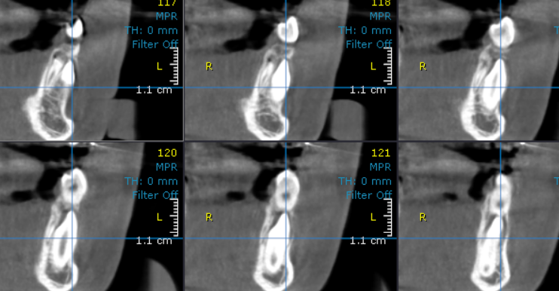
Impacted supernumerary tooth | 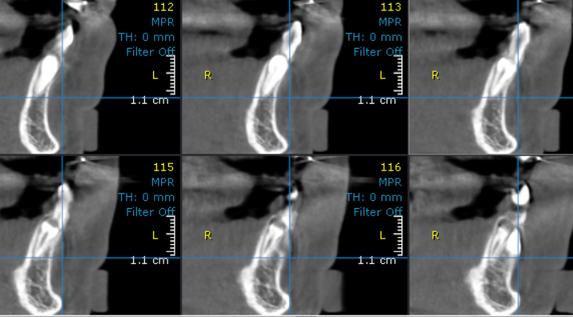

3-DIMENSIONAL VIEW

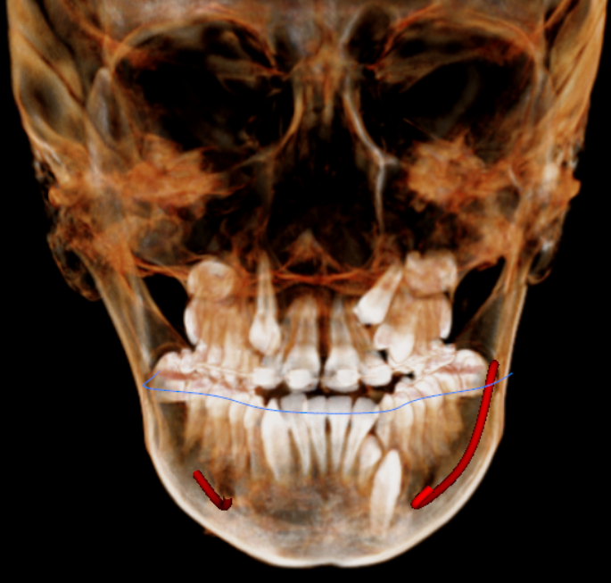

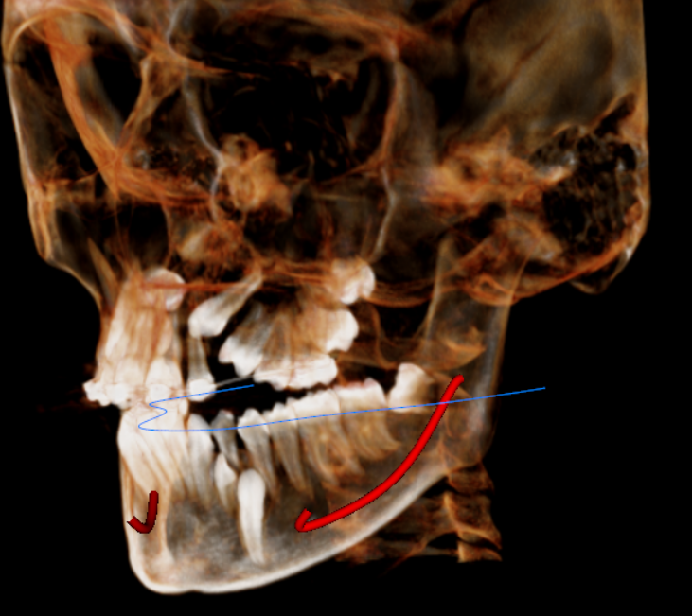

Impacted 23

Deciduous tooth : 73

Impacted Supernumerary tooth

Impacted 33

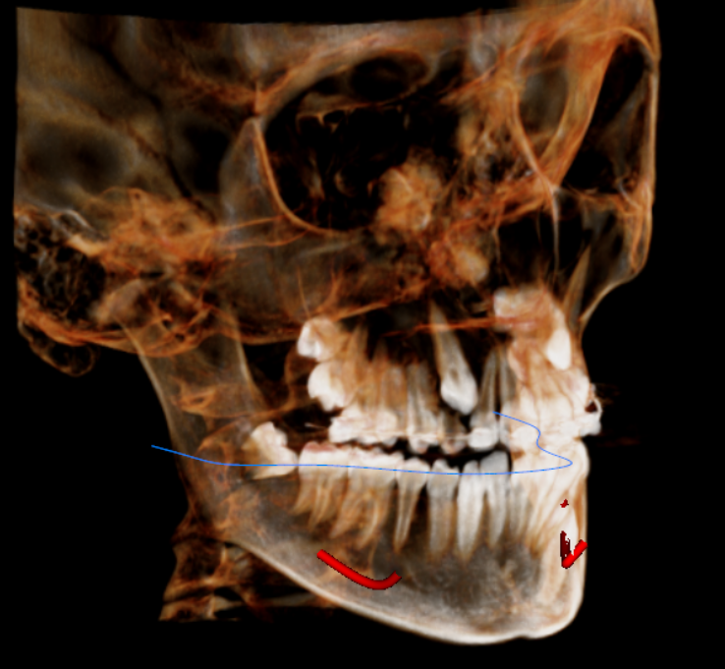

Permanent successor: 13

Deciduous tooth : 53

**** End of report ****

